Main Landing Page
Note: Menu: Retain from Global website

Hero-Sliding Carousel
- Hero headline
- Product-focused rotating carousel
- Featured items: Gartner, Data Privacy, Posidex MDM, AML Screen, Rating
  - Each slide includes a 'Learn More' CTA button
    - Each product card Screen entity / product detail on hover/click
      - Consider adding a sub-headline per slide (e.g. '10x faster. 99.5% accurate.')
    - Include a Request Demo CTA alongside 'Learn More' on hero slides

Client Slideshow
Note: Retain from Global website
- Remove: 'India's Largest Enterprises' label, & Keep: 'Largest Enterprises' label only
- Add a client count callout: e.g. '75+ Enterprise Clients' above the logo strip
- Include industry tags below logo strip: BFSI, Telecom, Retail, Government

MDM Overview Section
- About Posidex MDM
- Metrics & Facts
  - 10x speed
  - 99.5% accuracy
  - …and additional key stats
  - (Reference from Profisee Website)
  - 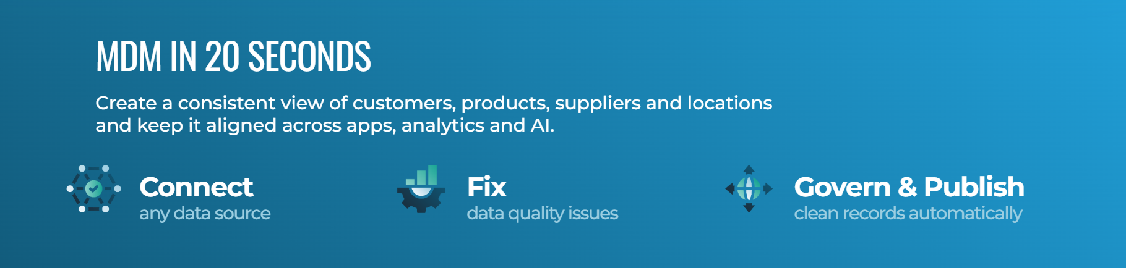
- Agentic Capabilities
- 'AI/ML model trained on 5 billion data points'
- 'Customer onboarding in 2 seconds'
- 'Manage 5 billion records in one go'
- 'Deployed in as fast as 3 months vs. industry standard of 1 year'
- 'Privacy by design-federated architecture supporting GDPR, DPDPA, data localization

Why Posidex
- Dedicated section explaining Posidex's value proposition
- Example
- 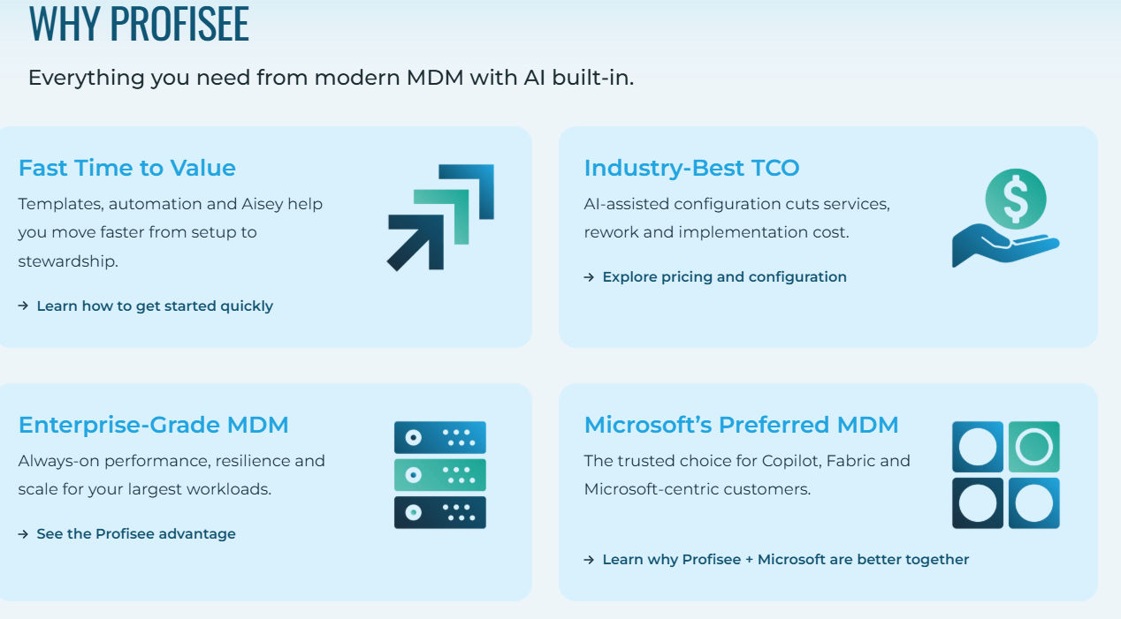
- Suggested talking points:
  - 20+ years of deep-tech innovation in customer data management
  - Purpose-built for enterprises-not a generic MDM solution
  - Low Total Cost of Ownership (TCO) vs. global MNC competitors
  - Minimal infrastructure requirements
  - Highly configurable and integrates with existing systems

Customer Reviews
- Customer testimonials / review section
- Source reviews from Gartner Peer Insights-already publicly available
- Highlight verticals in each testimonial (e.g. 'Leading Private Sector Bank')
- Add a star rating or Gartner badge near the section header

Business Impact Section
Note: Retain from Global page
- Potential impact stats to surface: 750M+ records processed (LIC), etc. Along with industry specific stats PM Award for ITDMS solution
- Include use case categories: Customer Due Diligence, Golden Record, Cross Sell, Fraud Prevention

Industries Section
Note: Retain from Global page
- Industries to confirm are represented: Banking & Financial Services, Insurance, Government, Telecom, Retail, Stock Market

Awards & Recognition
- Prime Minister's Award for Excellence in Governance (ITDMS Solution)
- ITsAP Award for Research & Innovation
- Best Enterprise Software Product-HYSEA 2015
- 10 Fastest Growing Data Analytics Companies in India-Silicon Review 2016
- Mentioned in Gartner and NASSCOM research

Products

MDM-Prime MDM
About
- About / intro section for Prime MDM
- Position as: AI-powered, real-time Customer MDM built for enterprise scale
- Differentiator line: 'Unlike traditional MDMs, PrimeMDM is purpose-built for real-time performance, data accuracy, and privacy compliance'
Key Metrics
- Key stats and metrics
- Additional data points as relevant
- 10x processing speed vs. legacy MDM platforms
- 99.5% data accuracy
- 5 billion records capacity in a single run
- Customer onboarding completed in 2 seconds
- Deployment in as fast as 3 months
- AI/ML model trained on 5 billion data points
Screen Snippets
- MDM screen snippet visuals
- Accompanied by short videos covering major aspects of the product
- Suggested video topics: onboarding flow, deduplication demo, entity resolution, dashboard overview
"Only Prime MDM Gives You" Section
Note: Retain from MDM Global page
- Differentiator highlights exclusive to Prime MDM
- Suggested differentiators to highlight: end-to-end encryption during processing, federated global customer search, privacy-by-design architecture, GDPR/DPDPA/CCPA compliance built-in
What Capabilities / Modules
- Modules: 360, Relate, Primever, Clip
- Hover interaction: tooltip / tab appears on hover for each module
  - Provides a quick glimpse of what the module does
  - 'Learn More' button → navigates to individual module page
- Add module one-liners for hover cards with call-to-action buttons to redirect the individual pages:
  - Prime 360-Real-time entity search and match (Retain from Global Page)
  - CLIP-Customer linking & identification (Retain from Global Page)
  - Relate-Network relationship discovery (Retain from Global Page)
  - PrimeVer-Automated customer info validation (Retain from Global Page)
  - PropEx-Collateral credit risk deduplication (Retain from Global Page)
Demo
- Screen MDM snippets and/or short videos
- Features overview
- Benefits overview
- Suggested demo flow: customer onboarding → name screening → alert generation → compliance report
- Feature to highlight handles all name permutations and combinations across languages/scripts

AML Screen
About
- About / intro for AML Screen product and cloud screenentity offering
- Sliding carousel covering: AML screen & Screen entities
- Position as: Global Watchlist & Sanctions Screening for AML, KYC, and EDD compliance
- Mention: screens against 2,100+ global watchlists including OFAC, UN Sanctions List, and PEP lists
Key Metrics
- Database connected
- Matching accuracy
- Search score…and additional key metrics
- Highlight: 2,100+ global watchlists covered
- Highlight: Daily updated lists for continuous monitoring
- Highlight: Real-time alerts for compliance checks
- Highlight: Supports KYC, AML, CFT, and EDD regulatory frameworks
- List out the databases included in the product excluding the DowJones & Dilisense (can mention as add databases)
- Integration highlight and flexibility.
Demo
- Screen snippets and/or short videos
- Features overview
- Benefits overview
- Suggested demo flow: customer onboarding → name screening → alert generation → compliance report
- Feature to highlight handles all name permutations and combinations across languages/scripts

PII Data Vault
Note: Retain everything from Global page
- Full content and structure to be carried over from the existing Global page
- Key message to retain: 'Search, match & process encrypted PII without ever decrypting it'
- Key stats to surface: $4.88M average cost per data breach (IBM 2024)-contextualises the problem
- Highlight technology: Searchable encryption + proprietary polymorphic encryption algorithm
- Regulatory context to mention: GDPR, DPDPA, CCPA, data localization laws
- Launch highlight: Unveiled at Global Fintech Fest 2025 by PV Sindhu (strong PR hook)
- Zero data exposure-data stays encrypted at rest, in motion, and during processing

Design & Content Notes
- Global menu and navigation: Retain from Global website
- Client logos / slideshow: Remove regional qualifier, keep 'Largest Enterprises'
- All 'Retain from Global' sections: carry over content as-is, no rewriting
- Short videos: use for product demos, snippets, and feature highlights
- Hover states: add tooltips/tab interactions for module cards (360, Relate, Primever, Clip)
- Each product section to have a clear 'Learn More' / CTA leading to dedicated page
- Add a sticky 'Request a Demo' button in the global nav or floating on all pages
- Ensure mobile-responsive layout-carousel, module cards, and video snippets all need mobile testing
- SEO: Product pages should target terms like 'Customer MDM ', 'AML Screening Software', 'PII Data Protection'
- Add a 'Resources' or 'Insights' section link in nav: whitepapers, blogs, Gartner reports
- Language Toggle: Add Arabic language toggle to the site. Even a basic translated version sends a strong signal of regional commitment.
- Consider a comparison table: Posidex vs. traditional/global MDM solutions (TCO, speed, accuracy, deployment time).

